|  |  |  |  |
| --- | --- | --- | --- |
|  | Bansilal Ramnath Agarwal Charitable Trust's  Vishwakarma Institute of Information Technology  **Department of Artificial Intelligence and Data**  **Science** | | |
| Name: Siddhesh Dilip Khairnar | | | |
| Class: SY | Division: B | | Roll No: 272028 |
| Semester: IV | | Academic Year: 2022-2023 | |
| Subject Name & Code: Fundamentals of Computer Networks: ADUA22203 | | | |
| Title of Assignment: Write a program using TCP socket for wired network for following:  a. Say Hello to Each other b File transfer.  c. Calculator. | | | |
| Date of Performance: 27-04-2023 | | Date of Submission: 27-04-2023 | |

# Assignment No- 7

**Program and Output:**

# Say Hello to each other:

## Client:

#include <stdio.h> #include <sys/socket.h> #include <netinet/in.h> #include <string.h>

int main()

{

int clientSocket; char buffer[1024];

struct sockaddr_in serverAddr; socklen_t addr_size;

/*—- Create the socket. The three arguments are: —-*/

/* 1) Internet domain 2) Stream socket 3) Default protocol (TCP in this case) */ clientSocket = socket(PF_INET, SOCK_STREAM, 0);

/*—- Configure settings of the server address struct —-*/

/* Address family = Internet */ serverAddr.sin_family = AF_INET;

/* Set port number, using htons function to use proper byte order */ serverAddr.sin_port = htons(7891);

/* Set IP address to localhost */ serverAddr.sin_addr.s_addr = inet_addr("127.0.0.1");

/* Set all bits of the padding field to 0 */ memset(serverAddr.sin_zero, '\0', sizeof serverAddr.sin_zero);

/*—- Connect the socket to the server using the address struct —-*/ addr_size = sizeof serverAddr;

connect(clientSocket, (struct sockaddr *) &serverAddr, addr_size);

/*—- Read the message from the server into the buffer —-*/ recv(clientSocket, buffer, 1024, 0);

/*—- Print the received message —-*/ printf("Data received: %s",buffer);

return 0;

}

## Server:

#include <stdio.h> #include <sys/socket.h> #include <netinet/in.h> #include <string.h>

int main()

{

int welcomeSocket, newSocket; char buffer[1024];

struct sockaddr_in serverAddr;

struct sockaddr_storage serverStorage; socklen_t addr_size;

/*—- Create the socket. The three arguments are: —-*/

/* 1) Internet domain 2) Stream socket 3) Default protocol (TCP in this case) */ welcomeSocket = socket(PF_INET, SOCK_STREAM, 0);

/*—- Configure settings of the server address struct —-*/

/* Address family = Internet */ serverAddr.sin_family = AF_INET;

/* Set port number, using htons function to use proper byte order */ serverAddr.sin_port = htons(7891);

/* Set IP address to localhost */ serverAddr.sin_addr.s_addr = inet_addr("127.0.0.1");

/* Set all bits of the padding field to 0 */ memset(serverAddr.sin_zero, '\0', sizeof serverAddr.sin_zero);

/*—- Bind the address struct to the socket —-*/

bind(welcomeSocket, (struct sockaddr *) &serverAddr, sizeof(serverAddr));

/*—- Listen on the socket, with 5 max connection requests queued —-*/ if(listen(welcomeSocket,5)==0)

printf("Listening\n"); else printf("Error\n");

/*—- Accept call creates a new socket for the incoming connection —-*/ addr_size = sizeof serverStorage;

newSocket = accept(welcomeSocket, (struct sockaddr *) &serverStorage, &addr_size);

/*—- Send message to the socket of the incoming connection —-*/ strcpy(buffer,"Hello World\n");

send(newSocket,buffer,13,0);

return 0;

}

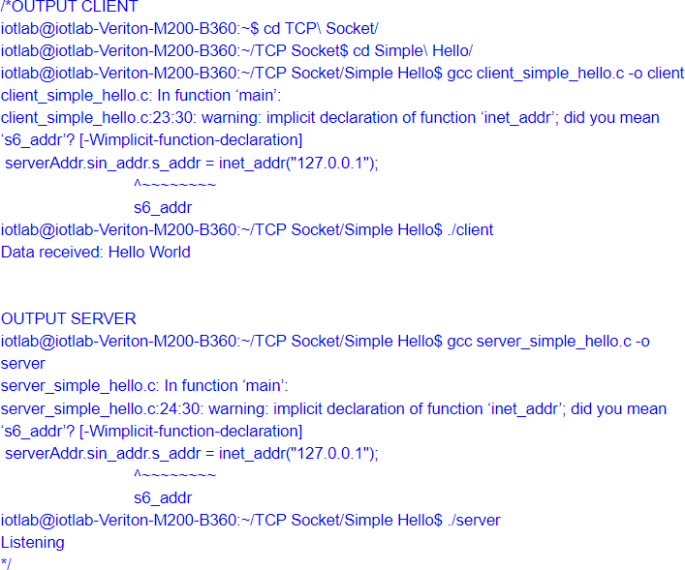

# File Transfer:

## Client:

#include <sys/socket.h> #include <sys/types.h> #include <netinet/in.h> #include <netdb.h> #include <stdio.h> #include <string.h> #include <stdlib.h> #include <unistd.h> #include <errno.h> #include <arpa/inet.h>

int main(void)

{

int sockfd = 0;

int bytesReceived = 0; char recvBuff[256];

memset(recvBuff, '0', sizeof(recvBuff)); struct sockaddr_in serv_addr;

/* Create a socket first */

if((sockfd = socket(AF_INET, SOCK_STREAM, 0))< 0)

{

printf("\n Error : Could not create socket \n"); return 1;

}

/* Initialize sockaddr_in data structure */ serv_addr.sin_family = AF_INET; serv_addr.sin_port = htons(5000); // port

serv_addr.sin_addr.s_addr = inet_addr("172.16.6.168");

/* Attempt a connection */

if(connect(sockfd, (struct sockaddr *)&serv_addr, sizeof(serv_addr))<0)

{

printf("\n Error : Connect Failed \n"); return 1;

}

/* Create file where data will be stored */ FILE *fp;

fp = fopen("sample_file.txt", "ab"); if(NULL == fp)

{

printf("Error opening file"); return 1;

}

/* Receive data in chunks of 256 bytes */ while((bytesReceived = read(sockfd, recvBuff, 256)) > 0)

{

printf("Bytes received %d\n",bytesReceived);

// recvBuff[n] = 0;

fwrite(recvBuff, 1,bytesReceived,fp);

// printf("%s \n", recvBuff);

}

if(bytesReceived < 0)

{

printf("\n Read Error \n");

}

return 0;

}

## Server:

#include <sys/socket.h> #include <netinet/in.h> #include <arpa/inet.h> #include <stdio.h> #include <stdlib.h> #include <unistd.h> #include <errno.h> #include <string.h> #include <sys/types.h>

int main(void)

{

int listenfd = 0; int connfd = 0;

struct sockaddr_in serv_addr; char sendBuff[1024];

int numrv;

listenfd = socket(AF_INET, SOCK_STREAM, 0); printf("Socket retrieve success\n");

memset(&serv_addr, '0', sizeof(serv_addr));

memset(sendBuff, '0', sizeof(sendBuff));

serv_addr.sin_family = AF_INET; serv_addr.sin_addr.s_addr = htonl(INADDR_ANY); serv_addr.sin_port = htons(5000);

bind(listenfd, (struct sockaddr*)&serv_addr,sizeof(serv_addr)); if(listen(listenfd, 10) == -1)

{

printf("Failed to listen\n"); return -1;

}

while(1)

{

connfd = accept(listenfd, (struct sockaddr*)NULL ,NULL);

/* Open the file that we wish to transfer */ FILE *fp = fopen("sample_file.txt","rb"); if(fp==NULL)

{

printf("File opern error"); return 1;

}

/* Read data from file and send it */ while(1)

{

/* First read file in chunks of 256 bytes */ unsigned char buff[256]={0};

int nread = fread(buff,1,256,fp); printf("Bytes read %d \n", nread);

/* If read was success, send data. */ if(nread > 0)

{

printf("Sending \n");

write(connfd, buff, nread);

}

/*

* There is something tricky going on with read ..
* Either there was error, or we reached end of file.

*/

if (nread < 256)

{

if (feof(fp))

printf("End of file\n"); if (ferror(fp))

printf("Error reading\n"); break;

}

}

close(connfd); sleep(1);

}

return 0;

}

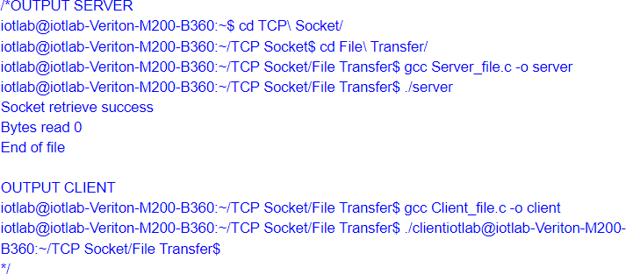

# Calculator:

**Client:** #include<sys/types.h> #include<sys/socket.h> #include<stdio.h> #include<netinet/in.h>

#include <unistd.h> #include<string.h> #include<strings.h> #include <arpa/inet.h>

//#define buffsize 150 void main()

{

int b,sockfd,sin_size,con,n,len; char operator;

int op1,op2,result; if((sockfd=socket(AF_INET,SOCK_STREAM,0))>0) printf("socket created sucessfully\n");

struct sockaddr_in servaddr; servaddr.sin_family=AF_INET; servaddr.sin_addr.s_addr=inet_addr("127.0.0.1"); servaddr.sin_port=6006;

sin_size = sizeof(struct sockaddr_in);

if((con=connect(sockfd,(struct sockaddr *) &servaddr, sin_size))==0); //initiate a connection on a socket

printf("connect sucessful\n");

printf("Enter operation:\n +:Addition \n -: Subtraction \n /: Division \n*:Multiplication \n"); scanf("%c",&operator);

printf("Enter operands:\n"); scanf("%d %d", &op1, &op2); write(sockfd,&operator,10); write(sockfd,&op1,sizeof(op1)); write(sockfd,&op2,sizeof(op2)); read(sockfd,&result,sizeof(result));

printf("Operation result from server=%d\n",result); close(sockfd);

## Server:

#include<sys/types.h> #include<sys/socket.h> #include<stdio.h> #include<netinet/in.h> #include <unistd.h> #include<string.h> #include <arpa/inet.h>

void main()

{

int b,sockfd,connfd,sin_size,l,n,len; char operator;

int op1,op2,result; if((sockfd=socket(AF_INET,SOCK_STREAM,0))>0) printf("socket created sucessfully\n"); //socket creation struct sockaddr_in servaddr;

struct sockaddr_in clientaddr; servaddr.sin_family=AF_INET;

servaddr.sin_addr.s_addr=inet_addr("127.0.0.1"); servaddr.sin_port=6006;

if((bind(sockfd, (struct sockaddr *)&servaddr,sizeof(servaddr)))==0) printf("bind sucessful\n"); //bind() assigns the

// address specified by addr to the socket referred to by the file

// descriptor sockfd. addrlen specifies the size, in bytes, of the

// address structure pointed to by addr. Traditionally, this operation is

// called “assigning a name to a socket”.

if((listen(sockfd,5))==0) //listen for connections on a socket printf("listen sucessful\n");

sin_size = sizeof(struct sockaddr_in);

if((connfd=accept(sockfd,(struct sockaddr *)&clientaddr,&sin_size))>0); printf("accept sucessful\n");

read(connfd, &operator,10); read(connfd,&op1,sizeof(op1)); read(connfd,&op2,sizeof(op2));

switch(operator)

{

case '+':

result=op1 + op2;

printf("Result is: %d + %d = %d\n",op1, op2, result); break;

case '-':

result=op1 - op2;

printf("Result is: %d - %d = %d\n",op1, op2, result); break;

case '*':

result=op1 * op2;

printf("Result is: %d * %d = %d\n",op1, op2, result); break;

case '/':

result=op1 / op2;

printf("Result is: %d / %d = %d\n",op1, op2, result); break;

default:

printf("ERROR: Unsupported Operation");

}

write(connfd,&result,sizeof(result)); close(sockfd);

}

